CS 555 HW 3

1. T6-13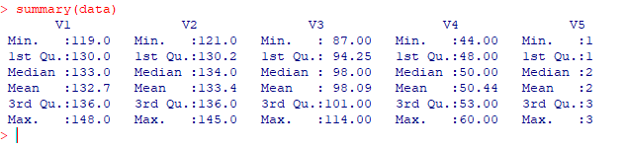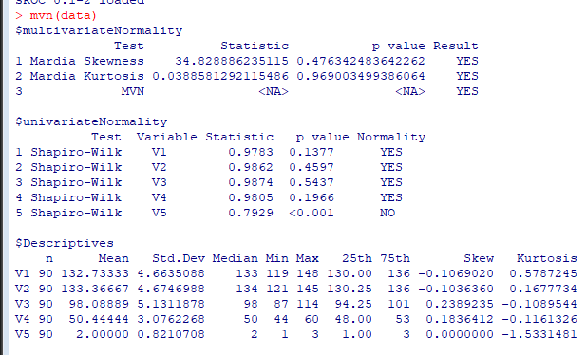
   1. V1, V2, V3, and V4 all appear to be quantitative datasets that are normally distributed. V5 is categorical data, specifically the time
   2. We are safe to assume univariate normality for V1 through V4, and are safe to assume Multivariate Normality across the entire dataset.
   3. 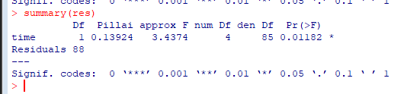 We reject the null multivariate-hypothesis that there were no changes in any of the four skull measurements over the three time periods, with an alpha level of 0.05.
   4. 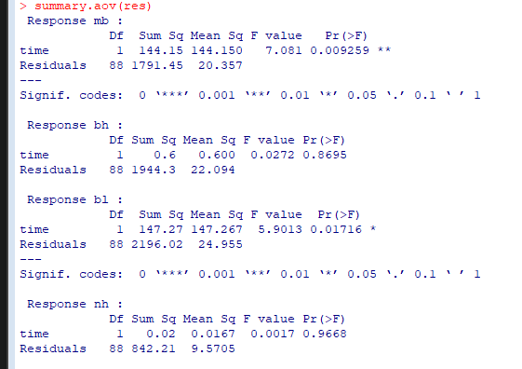 We fail to reject the null univariate hypotheses, that there was no difference in measurement based on the time period, for the Base Height and the Nasal Height measurements (V2 and V4) with an alpha level of 0.05.   
      We reject the null univariate hypotheses for the Max Breath and the Base Length measurements (V1 and V3) with an alpha level of 0.05.
   5. 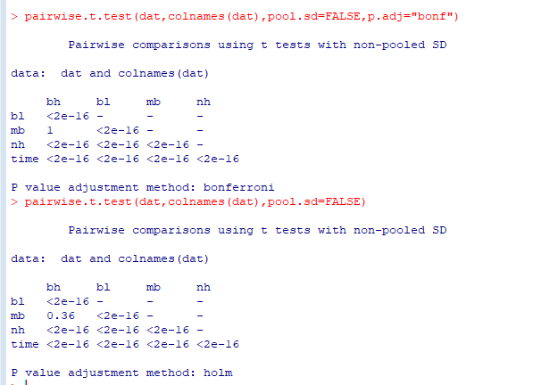  
      For standard and Bonferonni corrected pairwise T.Test all measures are significantly different from each other except for the Max Breath and the Base Height Measurements at an alpha level of 0.05.  
      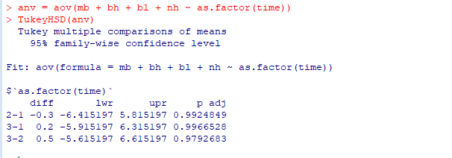  
      For Tukey’s correct HSD, each Time Period was significantly different to the other at an alpha level of 0.05.
2. Number Parity based on Format and Similarity
   1. There was a statistically significant difference between the reaction times in the recorded treatments between numbers represented by Arabic numerals compared to numbers represented by words in their place.
   2. 95% CI   
      WordDiff = 898.9859 – 1036.1391  
      WordSame = 775.2281-919.7406  
      ArabicDiff = 731.3008-863.0742  
      ArabicSame= 633.2839-749.2161
   3. The statistically significant interactions in these models were made up of two factors that were each already statistically significant for that model. (When looking at the reaction times of WordDiff, WordSame and ArabicDiff were significant, and the only significant interaction was between WordSame and ArabicDiff). This suggests that there was an absence of meaningful, statistically significant interaction effects, supporting the M model of numerical cognition.
   4. Despite the number of observations being high enough to be treated as normal, even accounting for the loss in observations for our estimations, the dataset is not Multivariate Normal, and only the WordDiff column is univariate normal, suggesting that it a multivariate-normal distribution is not appropriate for this dataset.